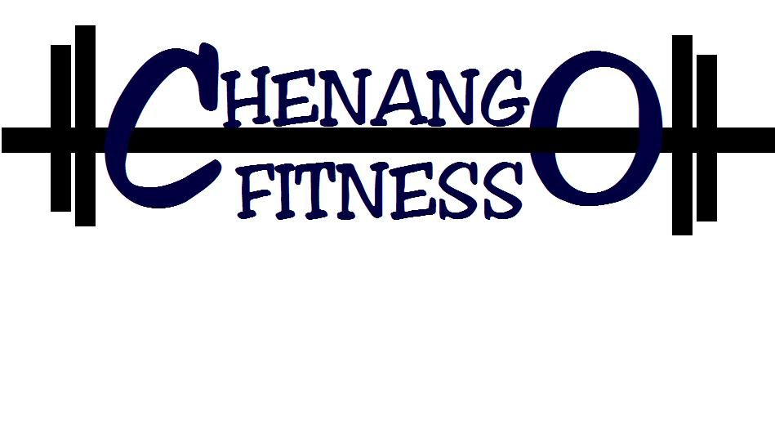
GUEST MEMBERSHIP INFORMATION AND AGREEMENT

Guest of: _______________________________________________________ (member name)

Name: __________________________________ Email: ___________________________________

Address: ________________________________ DOB: __________________

________________________________

Phone: __________________________________

I acknowledge that I am a guest of a member of Chenango Fitness LLC and hereby agree to abide by all the rules and regulations of the facility. Management has been contacted by phone, 703.350.1107 or by email at chenangofitness@yahoo.com and are aware of my presence at the gym and made aware of my length of use, a day or a week. I consent that I have completely filled out the form above and will place the appropriate payment in the designated box with this consent form. $5.00 for a day OR $15.00 for a week. Any intentions of using the gym any longer than a week or returning after a week as a guest again need to be approved by management.

Signature ____________________________________

Date_____________________________

Amount Paid _____________

Thanks
Stay Fit
Sara
703.350.1107

