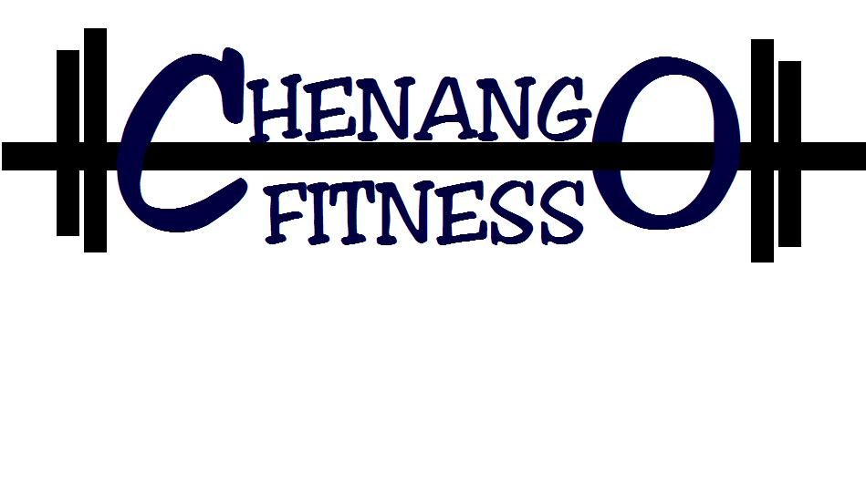
Cancellation Form

Today’s Date _______ Member Name(s):___________________________

Phone # ____________________ Email:____________________________

Reason for Cancellation ____________________________________________________________________________________________________________________________________________________________________________________________________________________________________________________

Would you consider freezing your membership instead of cancelling it? ___

Your membership will be cancelled the first of the following month if received by the 15th of the previous month, if received after the 15th of the month your membership will be cancelled after 30days. After 6 months of cancelling your membership you will be obligated to pay the enrollment fee to rejoin Chenango Fitness.

I have read and understand the above requirements and penalties for cancelling.

Signature: ____________________________________________________

